### ASSIGNMENT-2

|  |  |
| --- | --- |
| Assignment Date | 24 September 2022 |
| Student Name | R.Swathi |
| Student Roll Number | 2019504053 |
| Maximum Marks | 2 Marks |

### PYTHON PROGRAMMING

### SOURCE CODE:

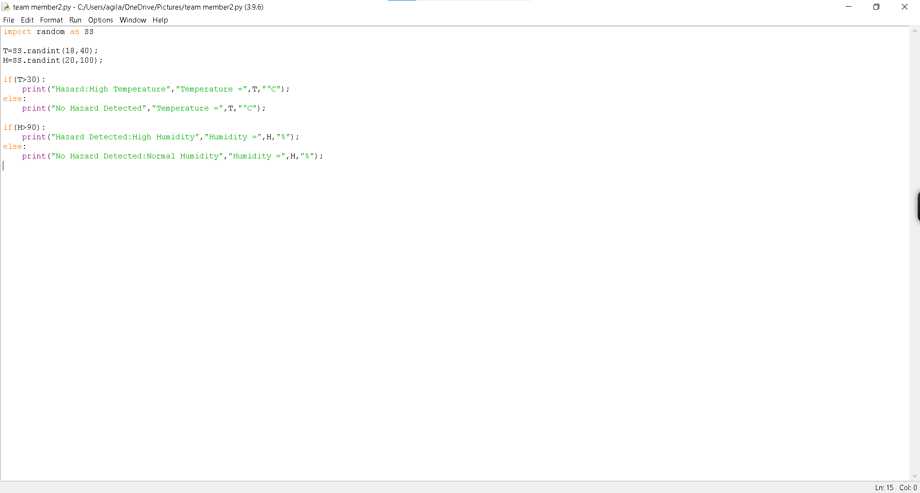

### RESULT:

